- Create numeric, character, and logical vectors and display type and content.
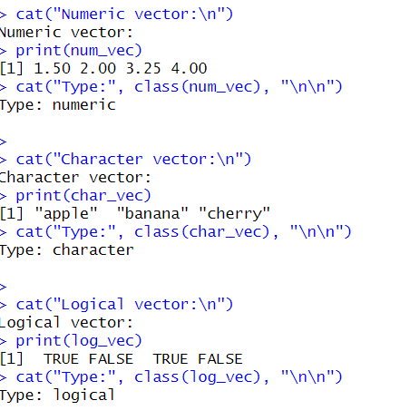
- Create labeled matrices (5×4, 3×3, 2×2) filled by row/column.
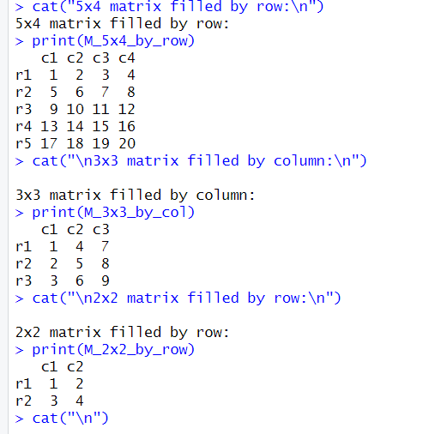

3. Write an R program to create and display a 3D array with specified rows, columns, and tables. 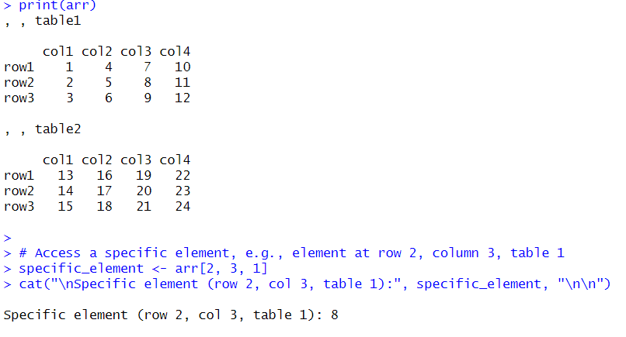
4. Create arrays from vectors with dimension names, print specific elements. 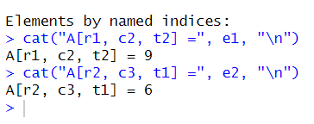
5. Create and manipulate factor variables (e.g., women’s dataset heights, random LETTERS sample). 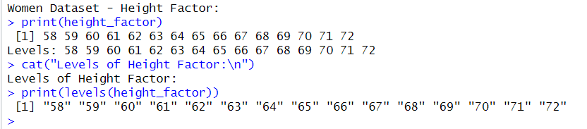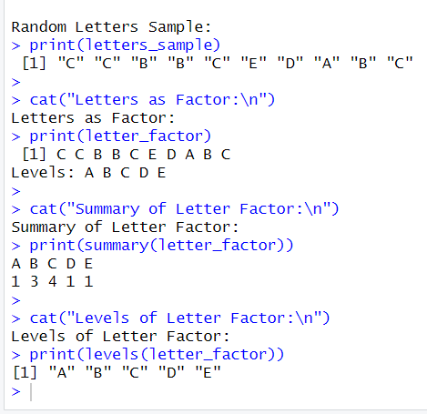
6. Create an R list containing vectors, matrices, and functions; display contents. 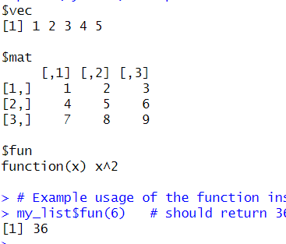
7. Write R programs for basic tasks: Factors of a number, generate a vector of 10 random integers
between -50 and 50, print numbers 1–100 with FizzBuzz logic. 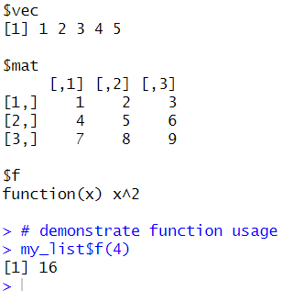
8. Generate random numbers from a normal distribution; count occurrences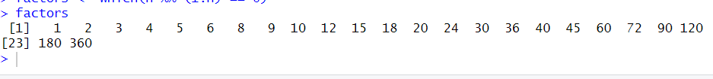.
9. Create empty plots with specified axis limits. 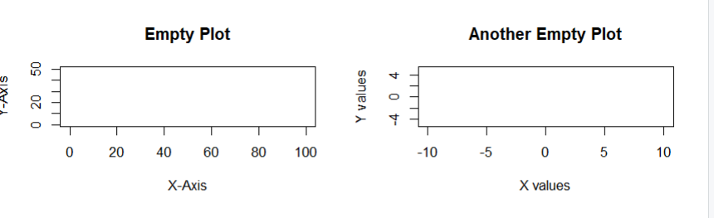
10. Create and explore a data frame exam_data with name, score, attempts, and qualify fields. Perform
extract, add row/column, sort, save to file. 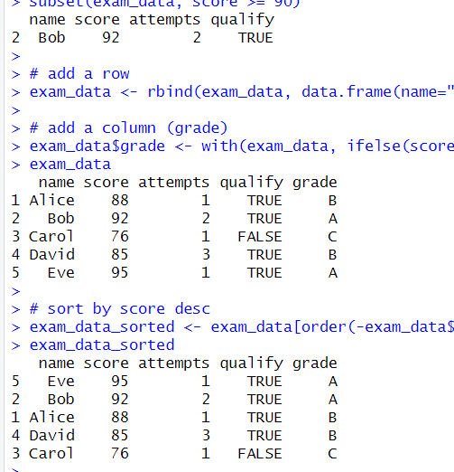
11. Write an R program to read a .csv file and display contents.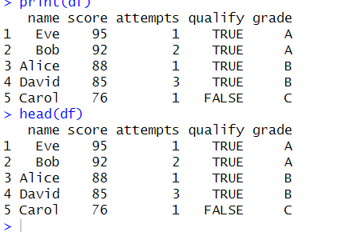
12. Perform data reshaping on airquality dataset: melt, cast, compute monthly averages for Ozone,
Solar.R, Wind, and Temperature.
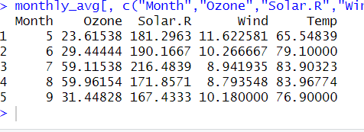

- Combine multiple arrays row-wise.
- 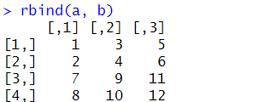
14.Explore and manipulate ChickWeight dataset (sorting, melting, casting by Diet).
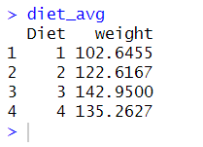
15. Perform EDA on iris dataset: dimensions, summary, standard deviation, quantiles, grouping by
Species, pivot table, categorical grouping with Sepal.Length categories.
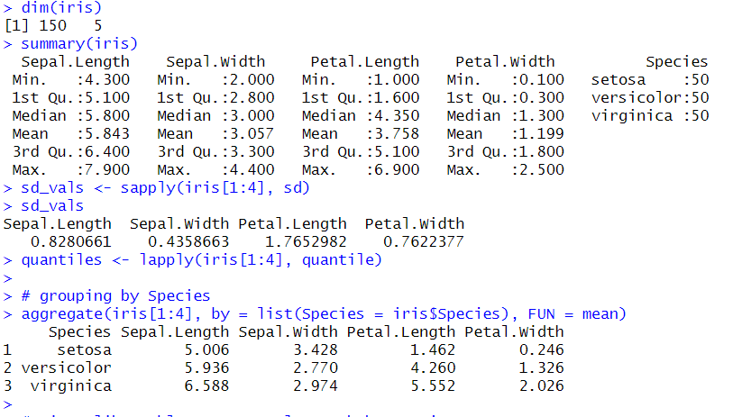
16. Explore USArrests dataset: summary statistics, state with largest rape arrests, max & min murder
rates, correlation among features, states above median assault arrests and bottom 25% for murder,
visualization with histogram, density, scatterplots, bar graphs.
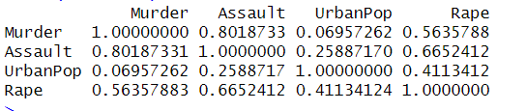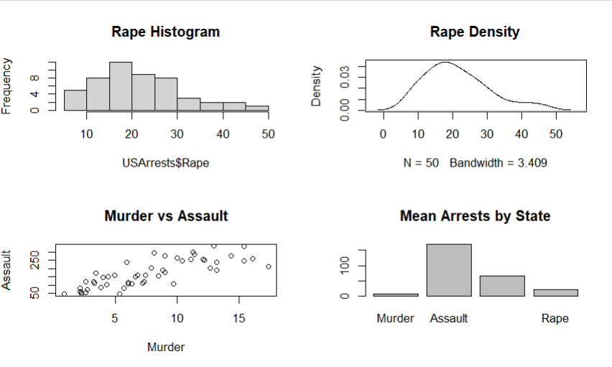
17. Explore Titanic dataset: bar chart of survival vs class, modify plot by gender, histogram of Age. 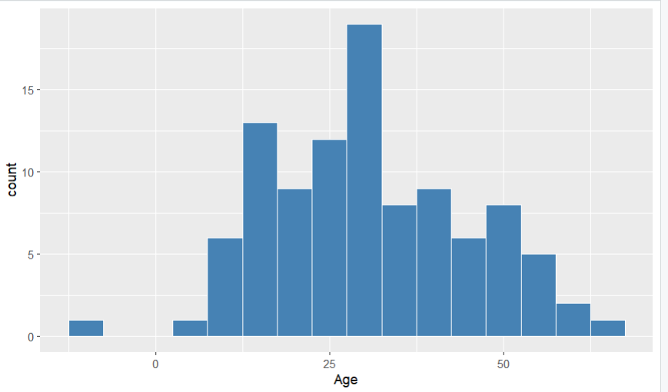
18. Create graphs in R: boxplot, histogram, bar plot, line chart, scatter plot.
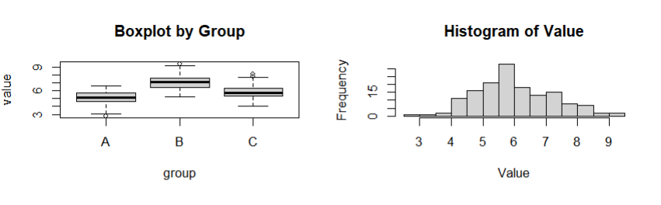
- Build a regression model on advertising dataset (Sales ~ Spend) and predict Sales.
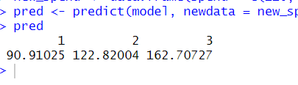
20. Create multiple regression model using ChickWeight dataset with “Time” and “Diet” as predictors;
predict weight and compute model error.
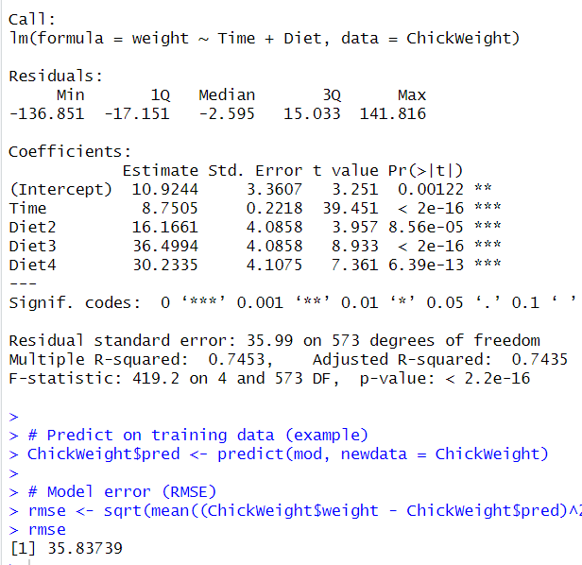
21. Randomly split iris dataset into train/test (80/20), build logistic regression (Species ~ Petal.Length +
Petal.Width), predict, and evaluate with confusion matrix.